Linked lists
Y13 - Cambridge International 9618 | Data Structures | Student booklet
Name: _______________________________ | Date: _____________

This booklet has everything you need for the lesson in one place. Work through it in order:
- Learn sections show the key slides. Read them carefully - they explain the ideas and show worked examples.
- Task sections are where you practise. Each task uses what the slides just before it taught you.
- Tasks get harder as you go, and are written like real Cambridge 9618 Paper 4 questions. Task 6 is done at the computer.
Task 1 Retrieval check [5 marks]
Circle True or False for each statement. If a statement is false, write a short correction.
Statement | True | False | Correction if false
The items in a linked list must be stored in consecutive array positions, in order.
Each node stores a data item and a pointer to the next node.
A pointer value of -1 shows the end of the list.
When a node is removed, the array elements after it are shuffled up to fill the gap.
A linked list stored in an array also needs a list of the free (empty) nodes.

Learn What is a linked list?
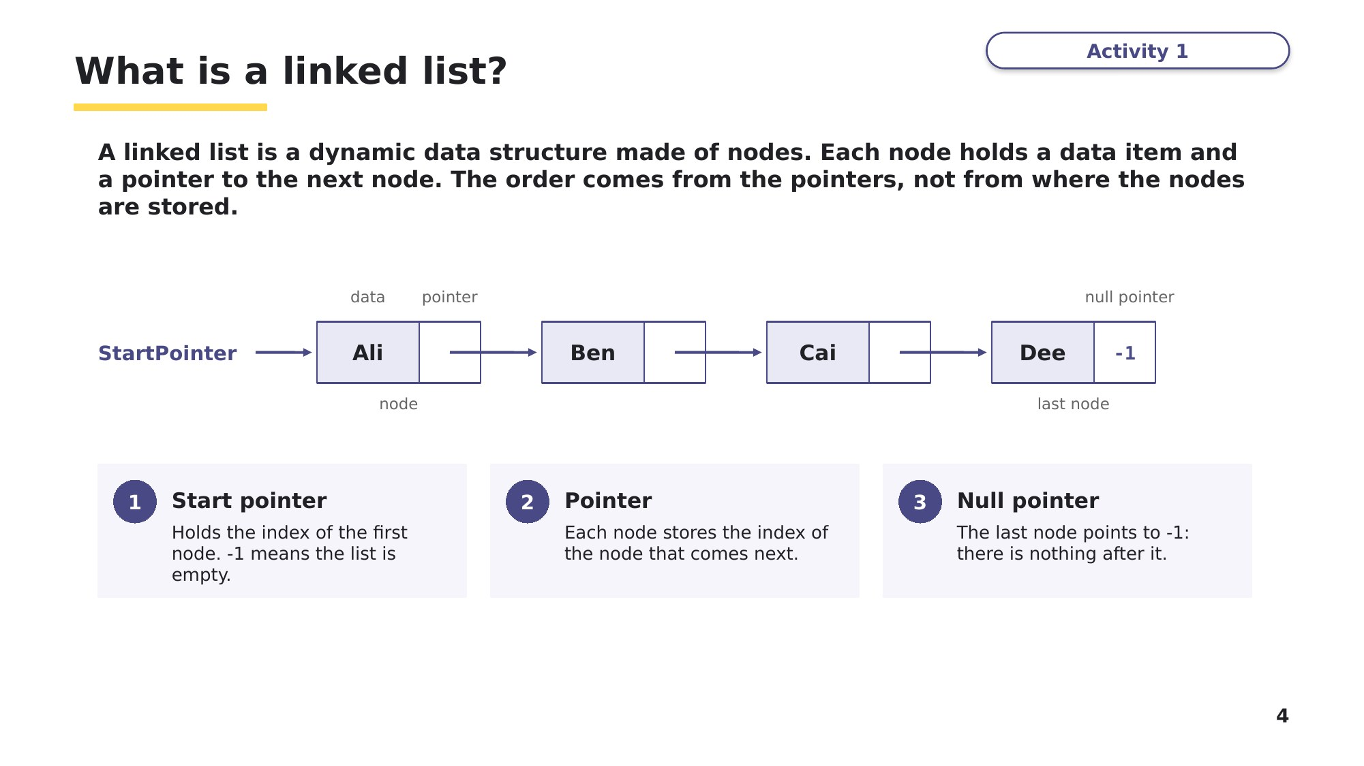
Slide 4 - What is a linked list?
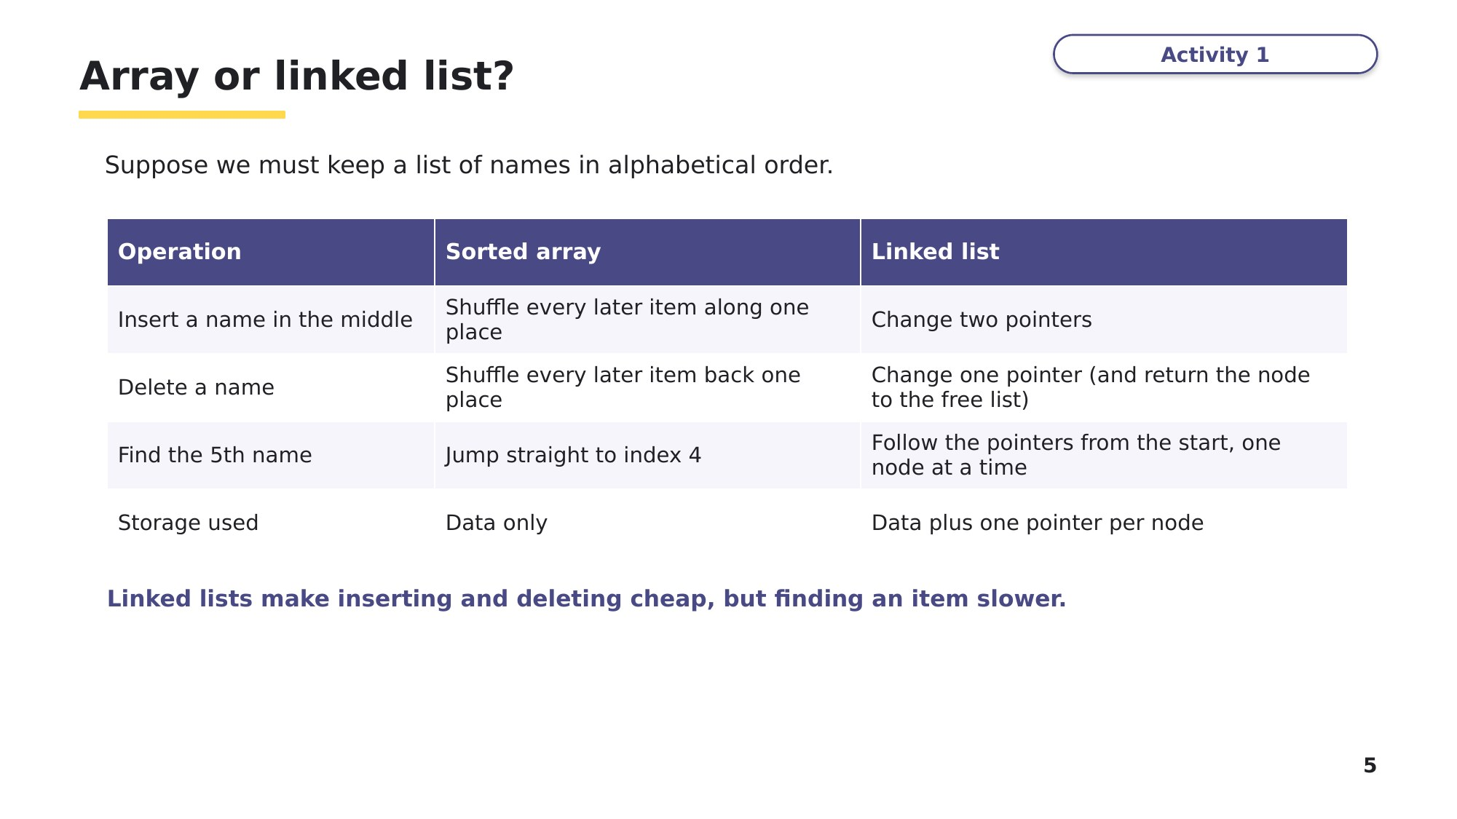
Slide 5 - Array or linked list?
Think, pair, share
A linked list makes inserting and deleting cheap, but you can only reach an item by following pointers from the start. With a partner: describe one program where a linked list is the better choice, and one where an ordinary array is better. Use the words "pointer" and "index".
Learn Storing a linked list in an array
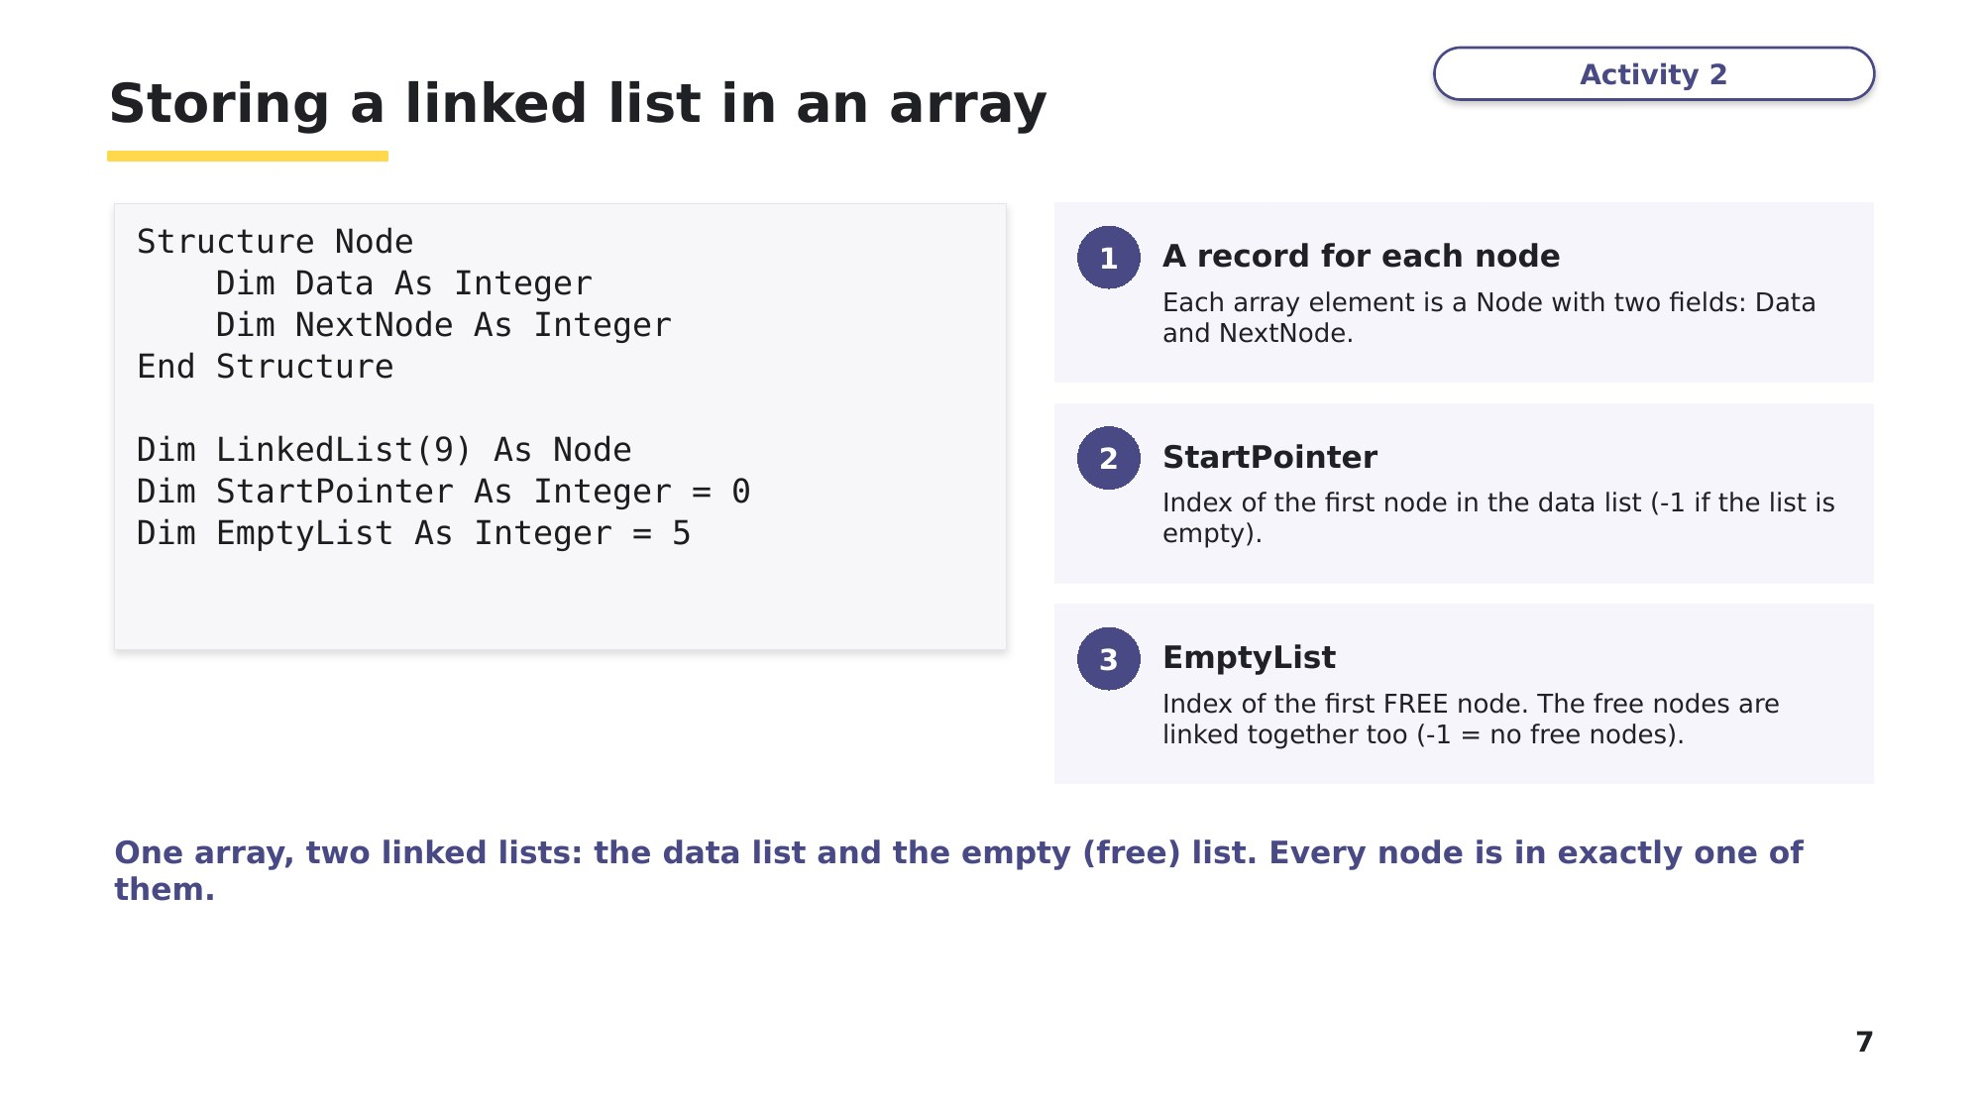
Slide 7 - Storing a linked list in an array
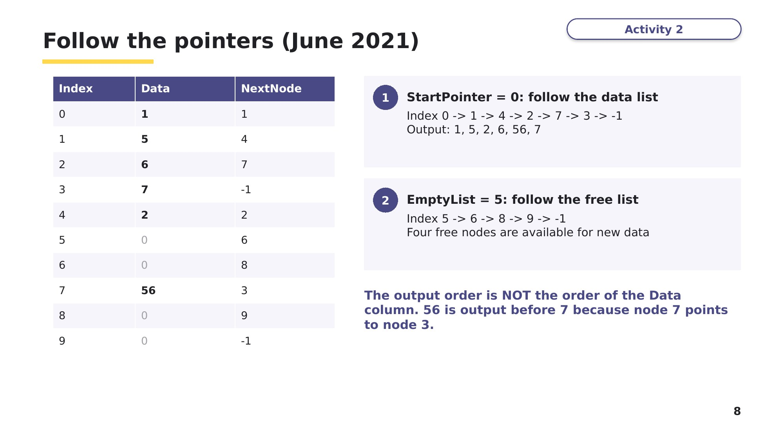
Slide 8 - Follow the pointers (June 2021)

Learn Traversing a linked list
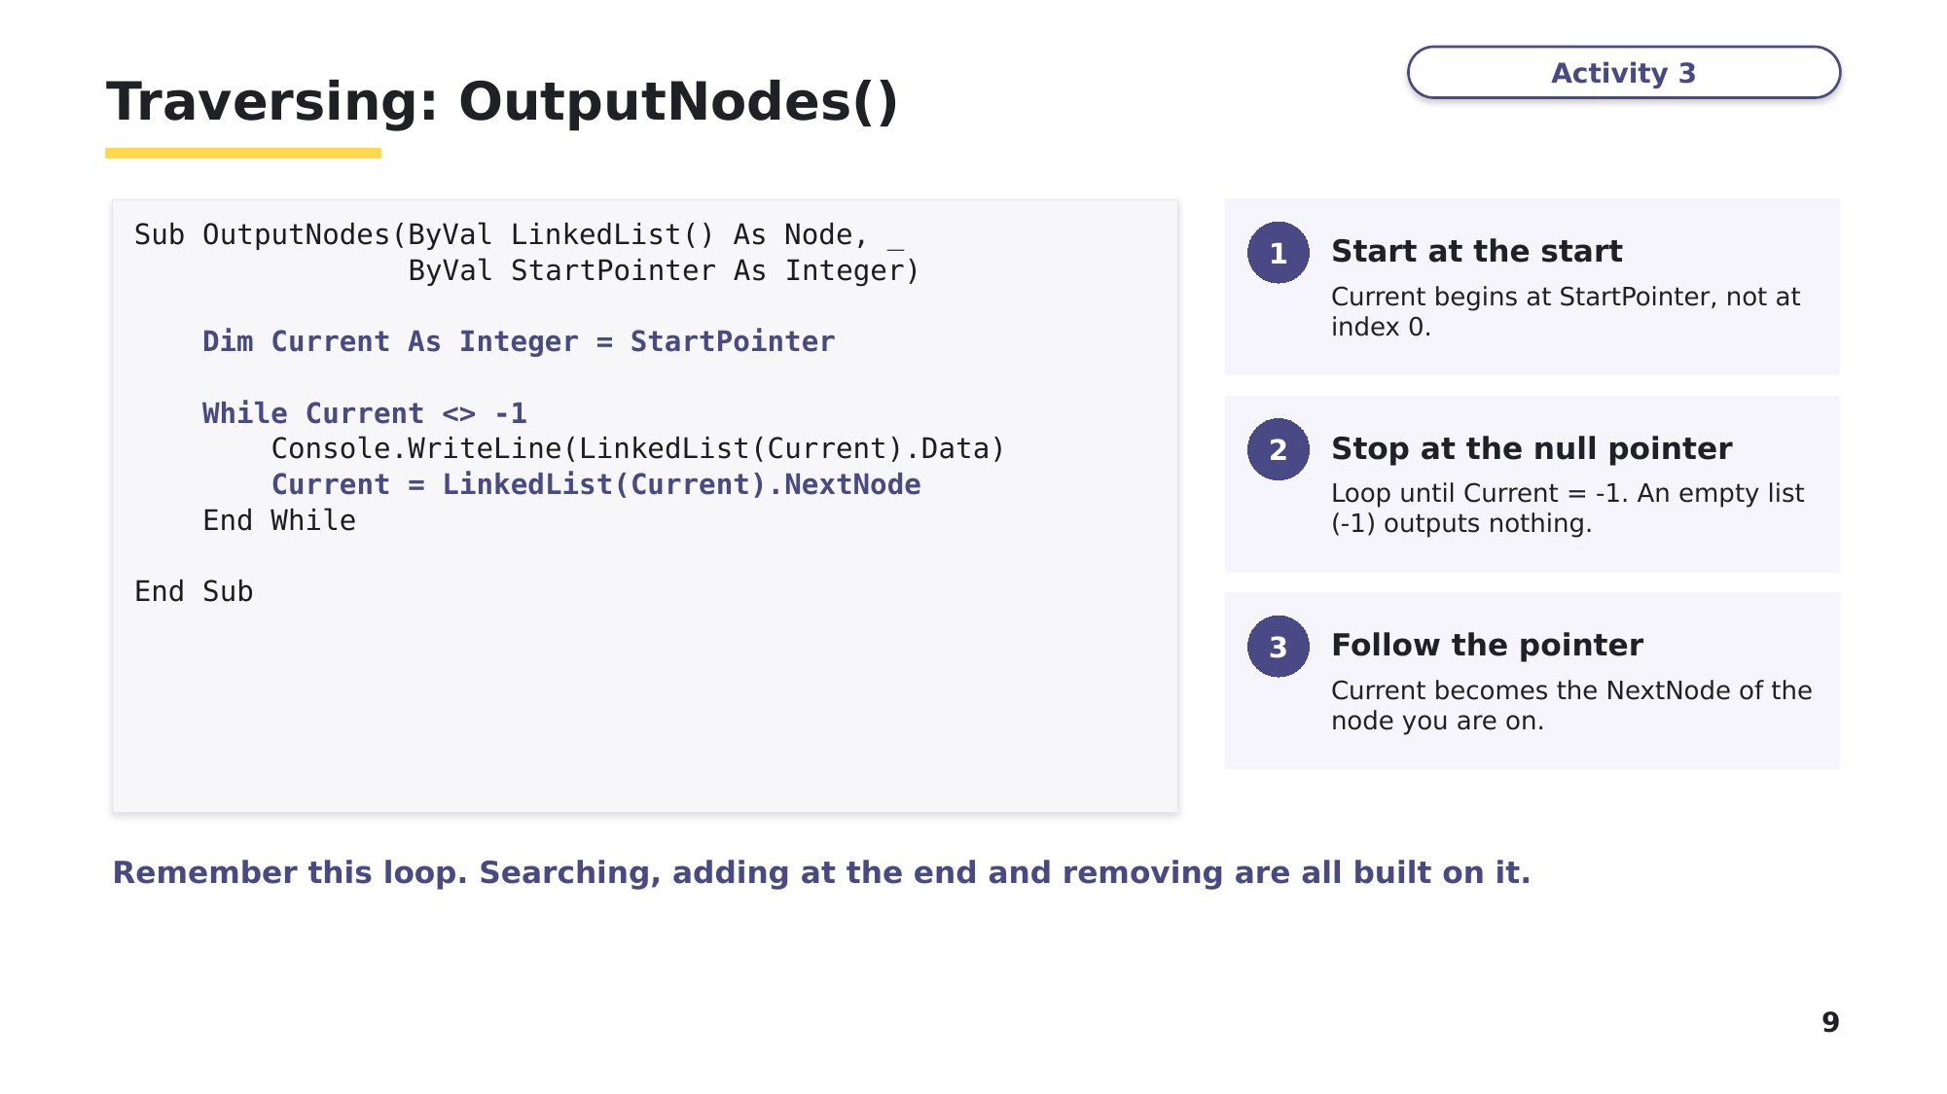
Slide 9 - Traversing: OutputNodes()
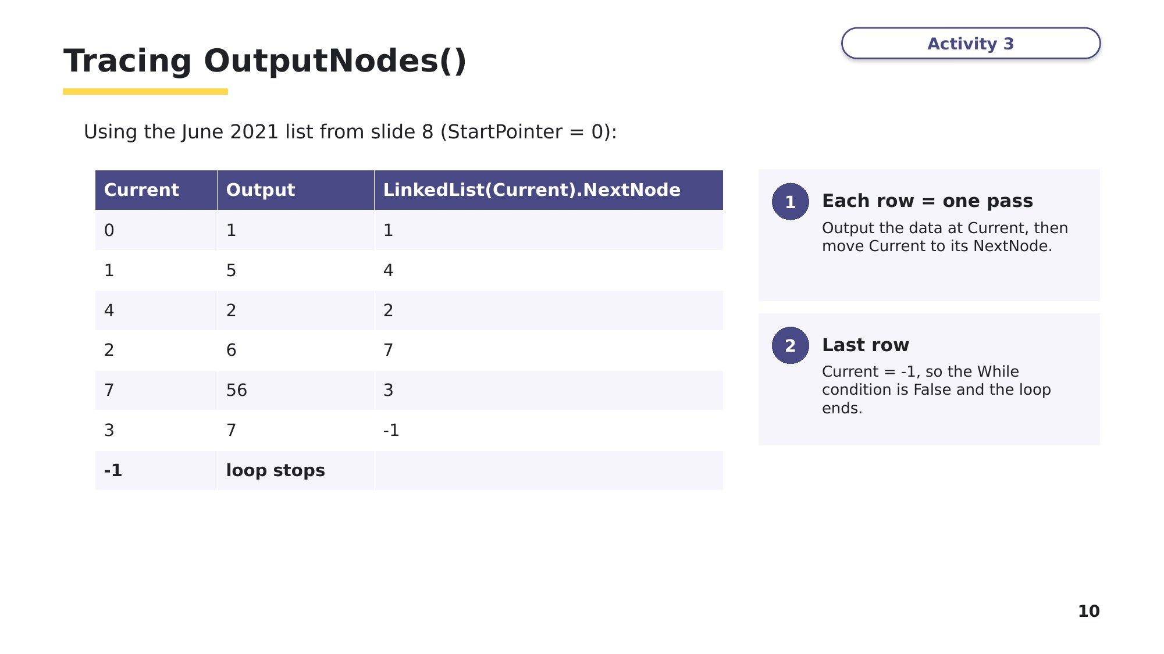
Slide 10 - Tracing OutputNodes()
Task 2 Tracing a linked list [10 marks]
A linked list is stored in LinkedList, a 1D array of Node records (fields Data and NextNode), exactly as in the lesson. StartPointer = 0 and EmptyList = 2.
Index | 0 | 1 | 2 | 3 | 4 | 5 | 6 | 7
Data | 17 | 42 | 0 | 8 | 29 | 13 | 0 | 0
NextNode | 3 | -1 | 6 | 5 | 1 | 4 | 7 | -1

Part A - Complete the trace table for OutputNodes(LinkedList, StartPointer). Then list the indexes of the free nodes, in the order they are linked. [3]
Current | Output | LinkedList(Current).NextNode
Free nodes, in order: ______________________________________

Learn Adding a node
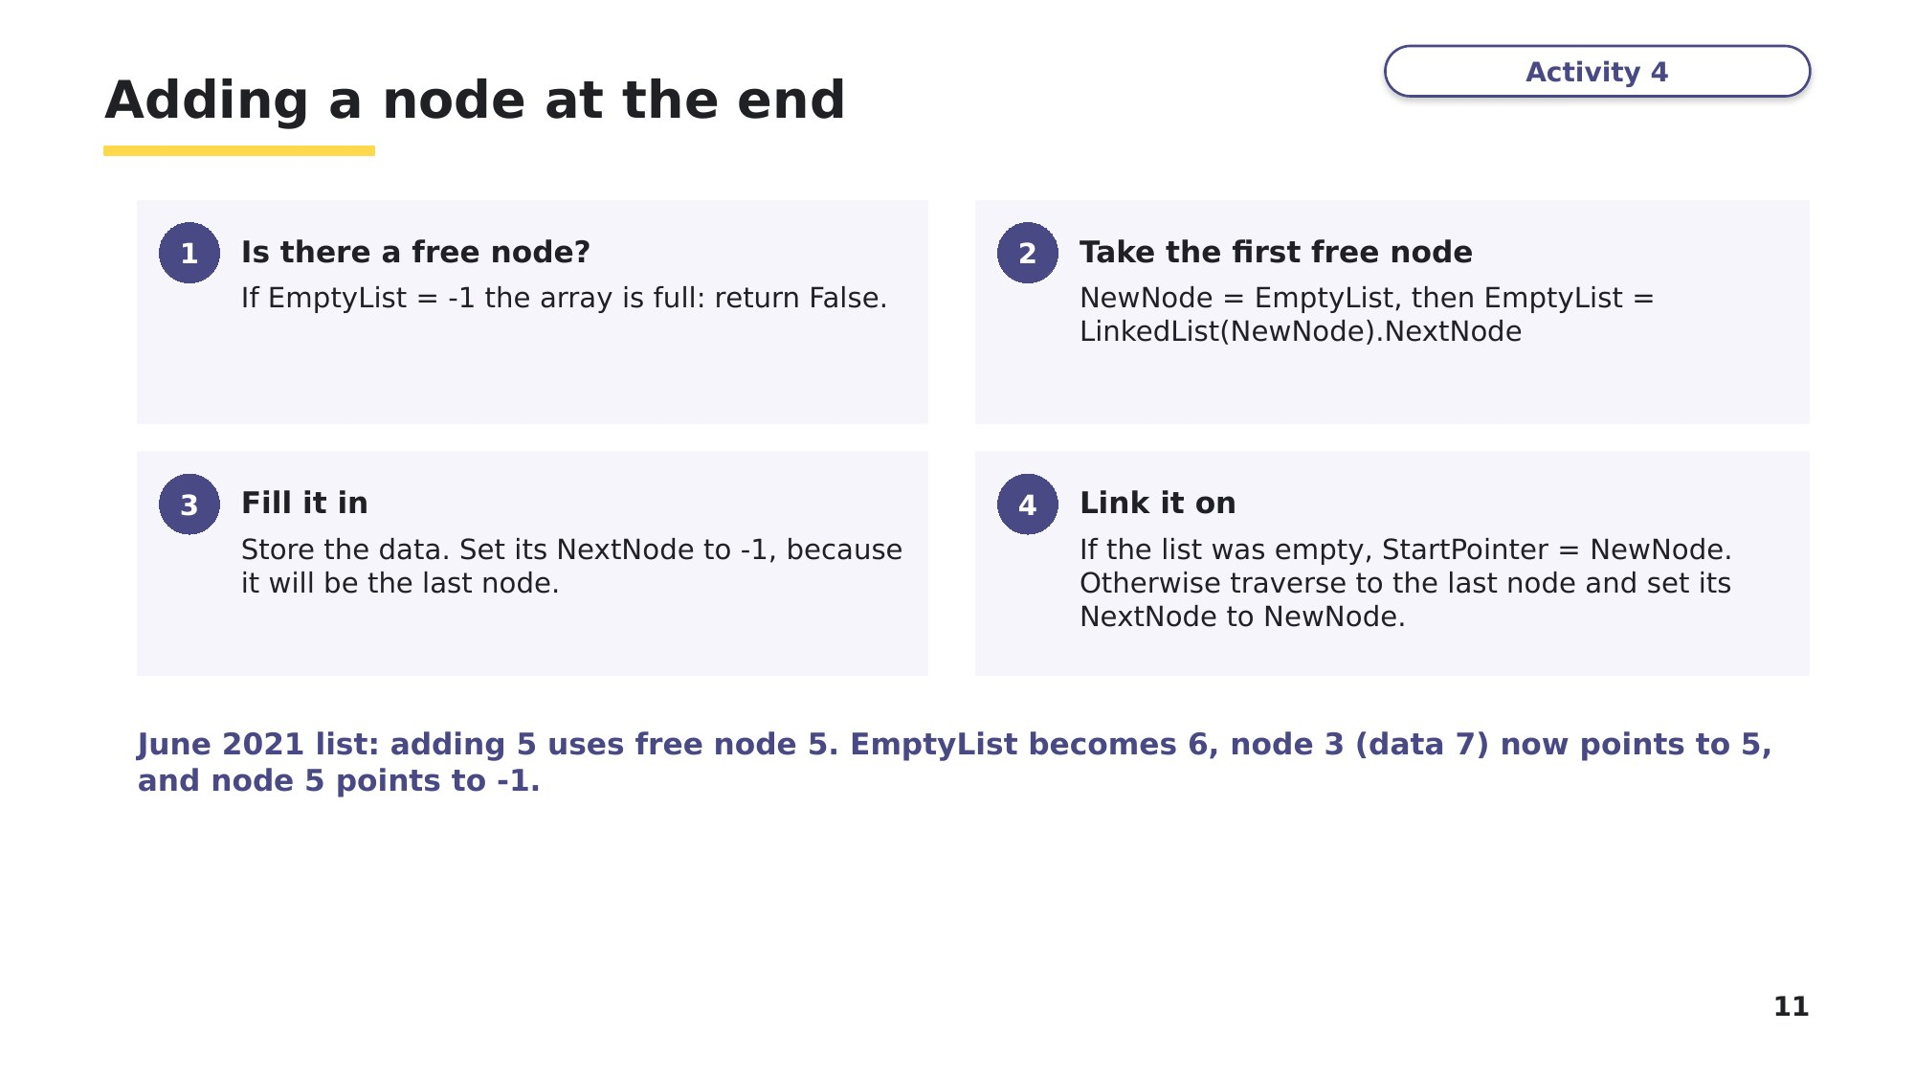
Slide 11 - Adding a node at the end
Slide 12 - Writing AddNode() in VB.NET
This is the June 2021 exam version: it adds the new node to the END of the list. The comments match the four steps on slide 11.
Function AddNode(ByRef LinkedList() As Node, ByRef StartPointer As Integer, _
ByRef EmptyList As Integer) As Boolean
Console.Write("Enter the data to add: ")
Dim DataToAdd As Integer = Integer.Parse(Console.ReadLine())
If EmptyList = -1 Then
Return False ' 1: no free nodes
End If
Dim NewNode As Integer = EmptyList ' 2: take the first free node
EmptyList = LinkedList(NewNode).NextNode ' free list moves on
LinkedList(NewNode).Data = DataToAdd ' 3: fill it in
LinkedList(NewNode).NextNode = -1 ' it will be the last node
If StartPointer = -1 Then
StartPointer = NewNode ' 4: the list was empty
Else
Dim Current As Integer = StartPointer
While LinkedList(Current).NextNode <> -1 ' find the last node
Current = LinkedList(Current).NextNode
End While
LinkedList(Current).NextNode = NewNode ' link it on
End If
Return True
End Function
Task 2 (continued)
Part B - AddNode() is now called to add the value 30 to the END of the list. Complete the table to show the values AFTER the call. [3]
Item | Value after AddNode(30)
The index of the node used to store 30 (NewNode)
EmptyList
LinkedList(NewNode).NextNode
NextNode of the node that stores 42

Learn Removing a node, and the 2D array version
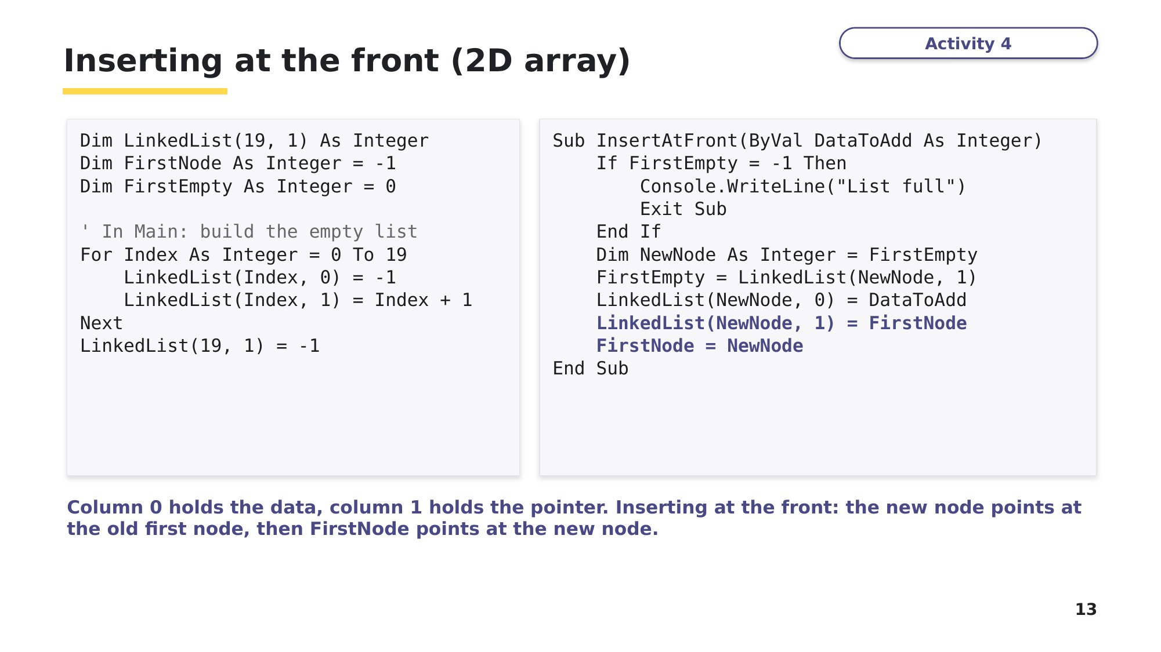
Slide 13 - Inserting at the front (2D array)
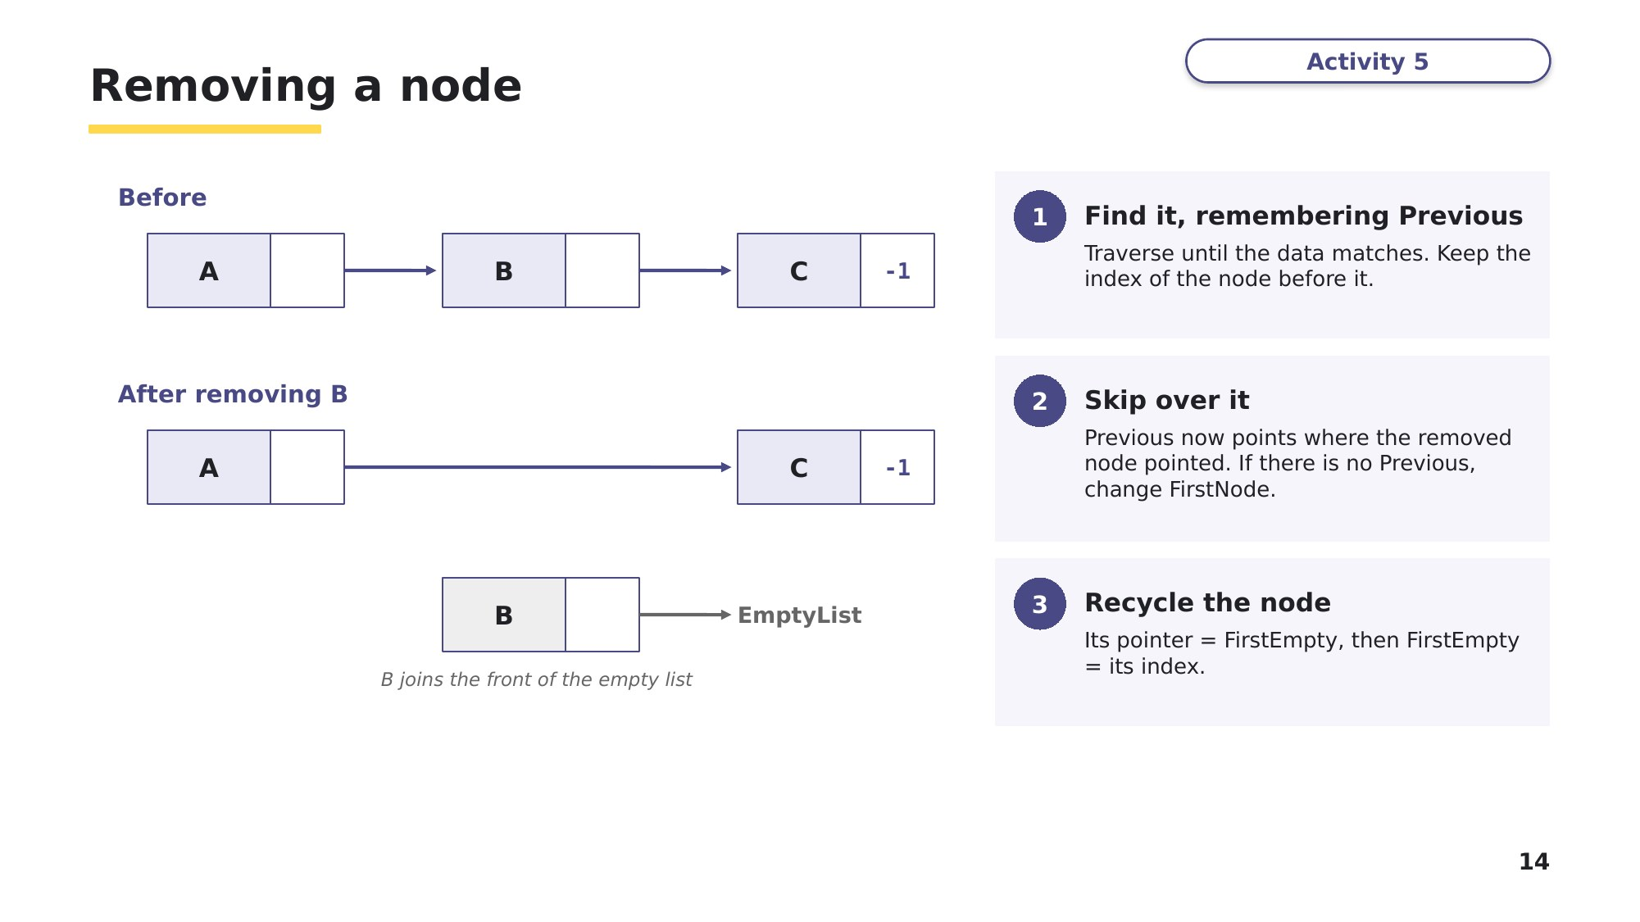
Slide 14 - Removing a node
Task 2 (continued)
Part C - RemoveData() is then called to remove the value 13. Complete the table. [4]
Item | Value after removing 13
LinkedList(3).NextNode
LinkedList(5).NextNode
EmptyList
The output of OutputNodes() now
Task 3 Complete the VB.NET code [5 marks]
This task uses the 2D array version from the lesson. LinkedList(19, 1) is a global 2D array: column 0 stores the data and column 1 stores the pointer. The global variables FirstNode and FirstEmpty store the index of the first node in the list and the first node in the empty list.
RemoveData() removes the first node containing DataToRemove and adds that node to the front of the empty list. You can assume DataToRemove is in the list. There are five gaps, numbered (1) to (5). Write the missing VB.NET code for each gap.
Sub RemoveData(ByVal DataToRemove As Integer)
Dim Current As Integer = FirstNode
Dim Previous As Integer = (1)........................
While LinkedList(Current, 0) <> DataToRemove
Previous = (2)........................
Current = LinkedList(Current, (3)........................)
End While
If Previous = -1 Then
FirstNode = LinkedList(Current, 1)
Else
LinkedList((4)........................, 1) = LinkedList(Current, 1)
End If
LinkedList(Current, 1) = (5)........................
FirstEmpty = Current
End Sub
(1) ______________ (2) ______________ (3) ______________ (4) ______________ (5) ______________

Learn Check your Task 3 answers
Only look at this slide once you have finished Task 3. Mark your own answers.
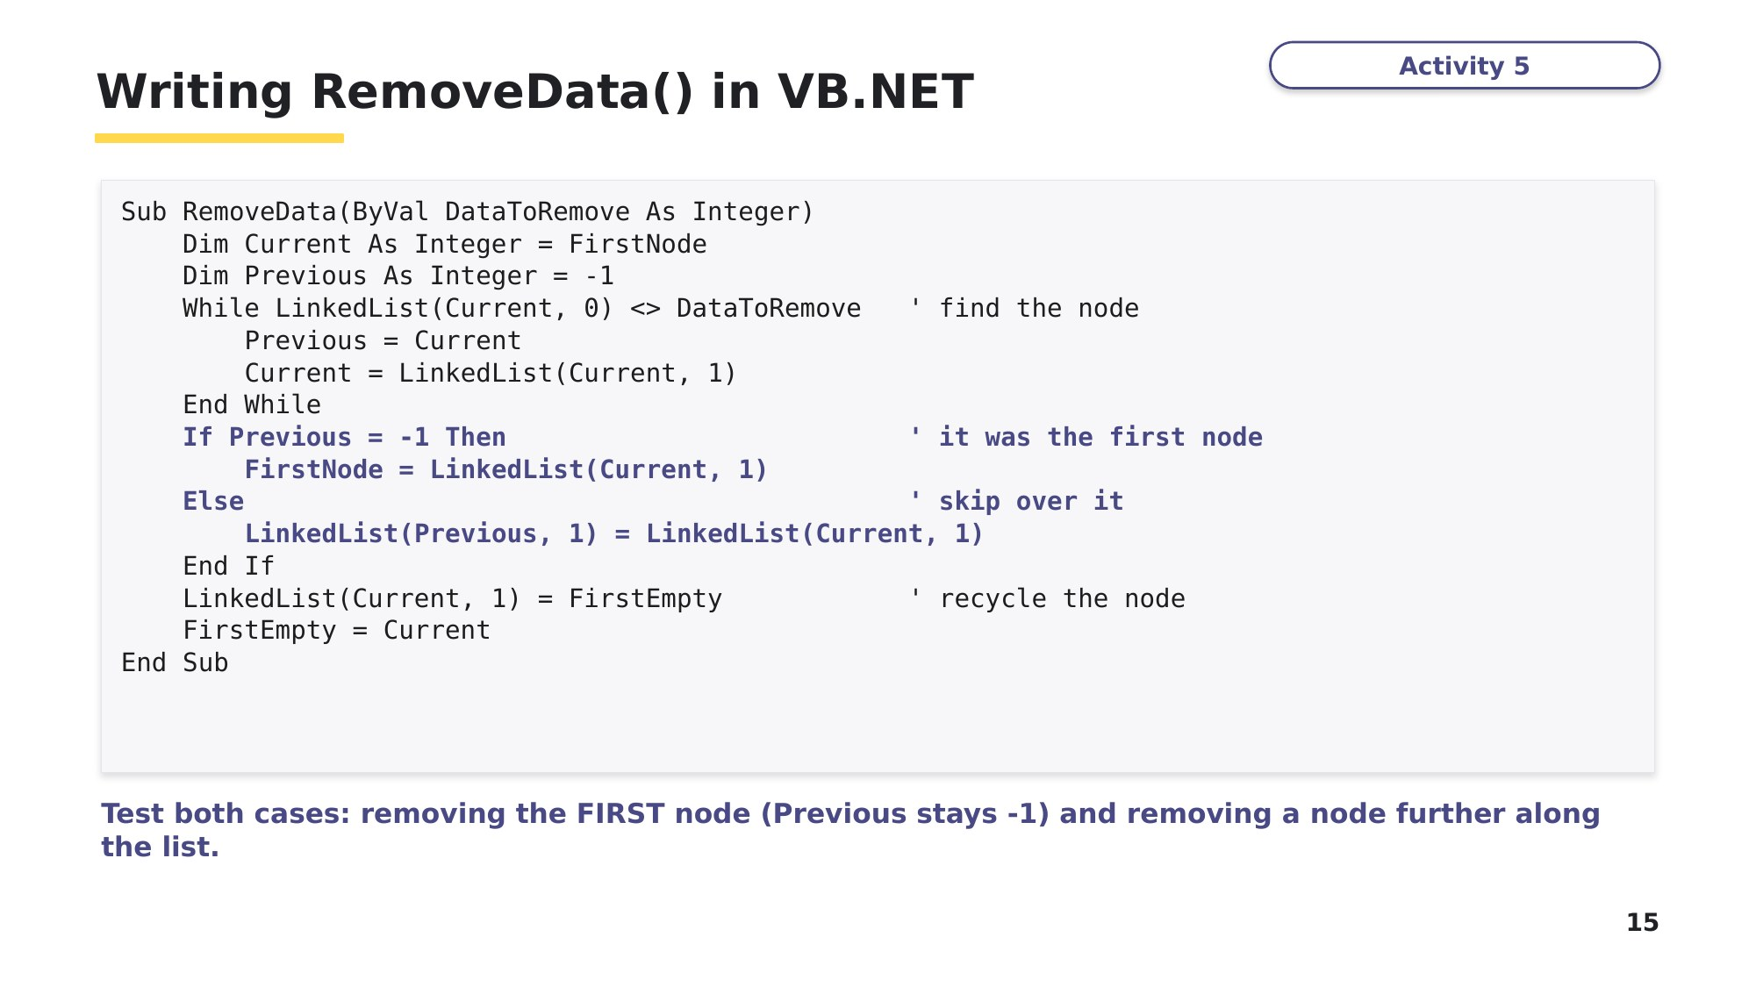
Slide 15 - Writing RemoveData() in VB.NET
Task 4 below uses the traversal loop from slide 9 - start from that shape.
Task 4 Write a function from a specification [8 marks]
This task is written in the same style as a real Cambridge 9618 Paper 4 question. Read the specification carefully before you write any code.
A linked list is stored in LinkedList, a 1D array of Node records, with StartPointer as in Task 2.
(a) Write program code for a function FindNode() that: [6]
- takes LinkedList, StartPointer and an integer DataToFind as parameters
- follows the pointers from StartPointer, checking each node in the list
- returns the index of the first node whose Data matches DataToFind
- returns -1 if DataToFind is not in the list.

(b) Using the table in Task 2 (before Part B), state what FindNode() would return for DataToFind = 29, and for DataToFind = 0. Explain the second answer. [2]

Task 5 Extension - find and fix the bugs
A student wrote AddNode() to add DataToAdd to the END of the list. It contains TWO errors. Identify each error, explain the effect it would have, and write the corrected code.
Function AddNode(ByRef LinkedList() As Node, ByRef StartPointer As Integer, _
ByRef EmptyList As Integer, ByVal DataToAdd As Integer) As Boolean
If EmptyList = -1 Then
Return False
End If
Dim NewNode As Integer = EmptyList
LinkedList(NewNode).Data = DataToAdd
LinkedList(NewNode).NextNode = -1 ' <-- line A
EmptyList = LinkedList(NewNode).NextNode
If StartPointer = -1 Then
StartPointer = NewNode
Else
Dim Current As Integer = StartPointer
While Current <> -1 ' <-- line B
Current = LinkedList(Current).NextNode
End While
LinkedList(Current).NextNode = NewNode
End If
Return True
End Function
Error 1 (line A):

Error 2 (line B):

Learn How you will be marked
Before you build the program in Task 6, read how examiners marked AddNode() in the real exam. The same ideas are marked in InsertData() and RemoveData(). Use it as a checklist for your own code.
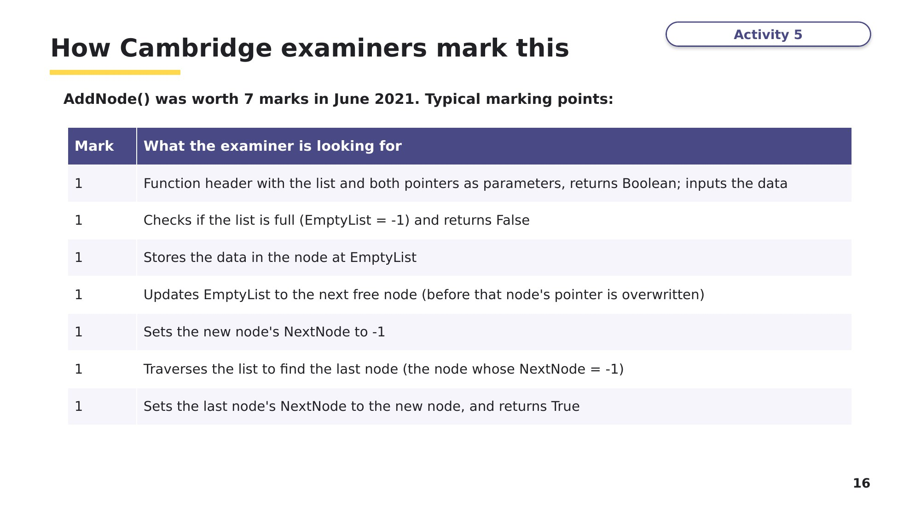
Slide 16 - How Cambridge examiners mark this
Task 6 Build it - at the computer [19 marks]
Based on Cambridge 9618 Paper 4, November 2024, Question 3. Create a new VB.NET console application called Question3_N24. Copy your code and screenshots into an evidence document as you go, exactly as you would in the exam.
A linked list stores positive integers in a global 2D array LinkedList that can hold 20 nodes. Column 0 stores the data and column 1 stores the pointer to the next node. A pointer of -1 marks the last node.
When the list is initialised, every node is in the empty list: each data value is -1, each pointer stores the index of the next node, and the last node (index 19) has the pointer -1. The global variable FirstEmpty is initialised to 0 and the global variable FirstNode is initialised to -1.
(a) Write program code for the main program to declare and initialise LinkedList, FirstNode and FirstEmpty. [2]
(b) The procedure InsertData() takes five positive integers as input from the user and inserts each one at the FRONT of the linked list. If the list is full, it outputs a suitable message and the procedure ends. Write program code for InsertData(). [6]
(c)(i) The procedure OutputLinkedList() outputs the data in the list, in order, by following the pointers from FirstNode. Write program code for OutputLinkedList(). [2]
(c)(ii) Amend the main program to call InsertData() and then OutputLinkedList(). [1]
(c)(iii) Predict first: if the inputs are 5, 1, 2, 3, 8 what will be output?

Now test your program with 5 1 2 3 8 and take a screenshot. Was your prediction right? [1]
(d)(i) The procedure RemoveData() takes the data item to remove as a parameter. It finds the first node containing that value, removes it from the list and adds it to the empty list, updating pointers as needed. Assume the item is in the list. Write program code for RemoveData(). [5]
(d)(ii) Amend the main program to call RemoveData() with the parameter 5, output the word "After", then call OutputLinkedList(). [1]
(d)(iii) Predict first, then test your program with both sets of test data and take a screenshot of each output. [1]
Test data | Predicted output before "After" | Predicted output after "After"
Set 1: 5 6 8 9 5
Set 2: 10 7 8 5 6
Stretch
Write a procedure InsertOrdered() that inserts a value into the list so the list stays in ascending order. Hint: traverse while the next node's data is smaller, remembering Previous - just like RemoveData(). Test it by inserting 50, 10, 30, 20, 40.

Learn Review
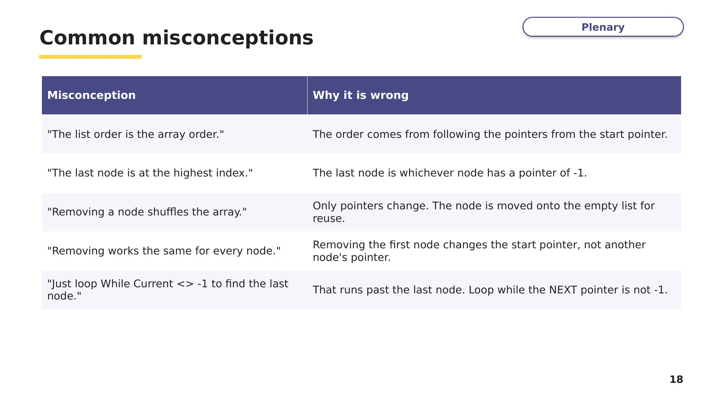
Slide 18 - Common misconceptions
Look back at your Task 1 answers. Correct any you got wrong, using what you have learned.
Exit question
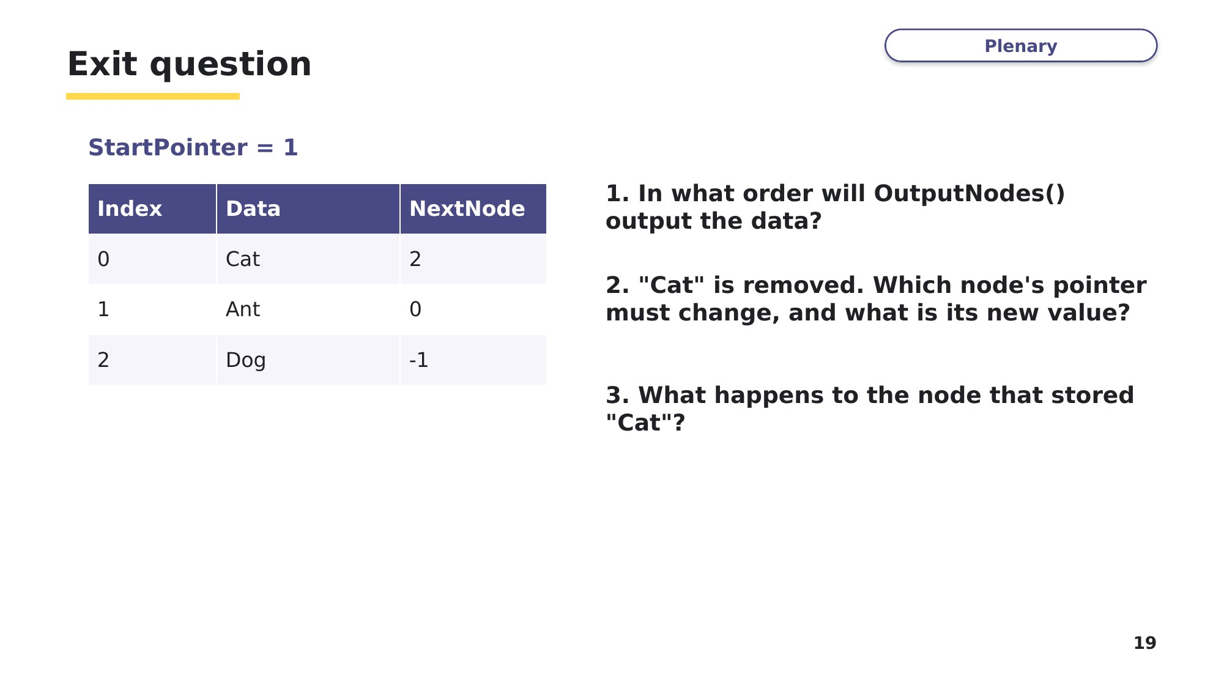
Slide 19 - Exit question

